**Bottom Navigation with Navigation Icon from Local Directory**

<https://aboutreact.com/react-native-bottom-navigation-icon-from-local/>

## Installation of Dependencies

1. Install react-navigation dependency to import createAppContainer

npm **install** react-navigation –save

1. Other supporting libraries for react-navigation

npm **install** react-**native**-gesture-**handler** react-**native**-**safe**-area-**context** @react-**native**-community/masked-**view** react-**native**-screens react-**native**-reanimated –save

1. Install react-navigation-tabs to import createBottomTabNavigator

npm **install** react-navigation-tabs –save

1. Install react-navigation-stack to import createStackNavigator

npm **install** react-navigation-stack –save

## Project File Structure

To start with this Example you need to create

1. A directory named pages in your project and create four files DetailsScreen.js, HomeScreen.js, ProfileScreen.js and SettingScreen.js in it.
2. A directory named asset which will have our icons stored.

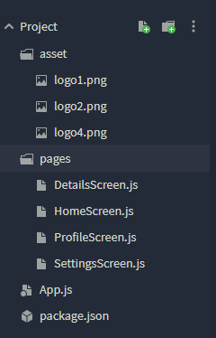

  

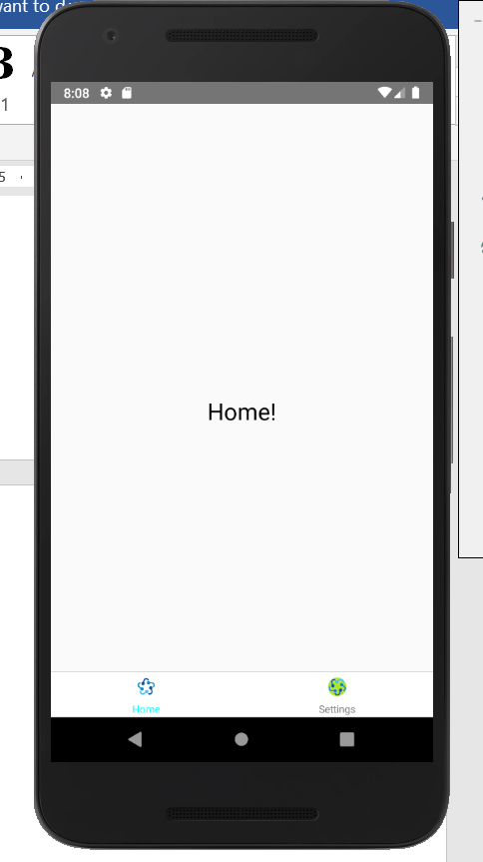 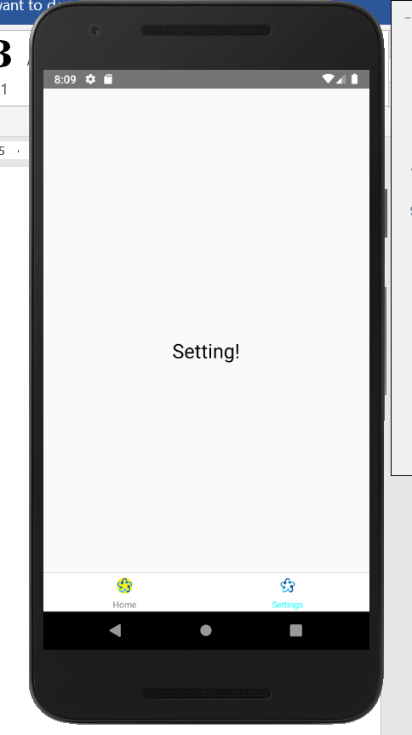

### **App.js**

//This is an example code for Bottom Navigation//

//Icons Used in this example is from local directory//

import React from 'react';

import { Button, Image } from 'react-native';

//Import React Navigation

import { createAppContainer } from 'react-navigation';

import { createBottomTabNavigator } from 'react-navigation-tabs';

import { createStackNavigator } from 'react-navigation-stack';

import HomeScreen from './pages/HomeScreen';

import SettingsScreen from './pages/SettingsScreen';

//Defination of Navigaton bottom options

const App = createBottomTabNavigator(

{

Home: { screen: HomeScreen },

Settings: { screen: SettingsScreen },

},

{

defaultNavigationOptions: ({ navigation }) => ({

tabBarIcon: ({ focused }) => {

const { routeName } = navigation.state;

if (routeName === 'Home') {

return (

<Image

source={

focused

? require('./asset/logo1.png')

: require('./asset/logo2.png')

}

style={{

width: 20,

height: 20,

borderRadius: 40 / 2,

}}

/>

);

*** } else if (routeName === 'Settings') {

} else if (routeName === 'Settings') {

return (

<Image

source={

focused

? require('./asset/logo1.png')

: require('./asset/logo4.png')

}

style={{

width: 20,

height: 20,

borderRadius: 40 / 2,

}}

/>

);

}

},

}),

tabBarOptions: {

activeTintColor: '#00FAFF',

inactiveTintColor: 'gray',

},

}

);

export default createAppContainer(App);

**HomeScreen.js**

import React from 'react';

import { Text, View } from 'react-native';

export default class HomeScreen extends React.Component {

//Home Screen to show in Home Option

render() {

return (

<View style={{ flex: 1, justifyContent: 'center', alignItems: 'center' }}>

<Text style={{ marginTop: 50, fontSize: 25 }}>Home!</Text>

</View>

);

}

}

**SettingSScreen.js**

import React from 'react';

import { Text, View, TouchableOpacity, StyleSheet } from 'react-native';

export default class SettingScreen extends React.Component {

//Setting Screen to show in Setting Option

render() {

return (

<View style={{ flex: 1, justifyContent: 'center', alignItems: 'center' }}>

<Text style={{ marginTop: 50, fontSize: 25 }}>Setting!</Text>

</View>

);

}

}